Due Tues Jan 29 – Please work out your answers them give me TWO PAGES MAXIMUM!

Please read the following (actual!) memo that was sent out to parents from my daughter’s school system when she was in the second grade (when Elana was in 2nd grade).

Memorandum
To: Parents of students on Bus #36
From: Transportation Dept, Carmel Clay Schools
Date: Aug 15, 2006-08-23
Re: Route Change

Due to changes in the route, the stop times may be changing. The new times are listed below.

t1 | 7: | 24 | CEDAR PT DR AND CEDAR PL
t2 | 7: | 25 | 10044 CEDAR PT DR
t3 | 7: | 25 | CEDAR PT DR AND MILL RUN |  |  |  | Elana boards here
t4 | 7: | 28 | 9944 CEDAR RIDGE DR
t5 | 7: | 29 | CEDAR PT DR AND MILL CREEK PL
t6 | 7: | 30 | 9632 CEDAR PT DR
t7 | 7: | 38 | 11040 QUEENS WAY CIR
t8 | 7: | 42 | 1011 W 116TH ST
t9 | 7: | 45 | HEARTAND HALL DAY CARE
t10 | 7: | 48 | W 111TH ST AND TOTTENHAM DR
t11 | 7: | 51 | MERSY CT AND TOTTENHAM DR
t12 | 7: | 53 | 11062 SPRINGMILL LANE
t13 | 7: | 54 | SPRING RIDGE CT AND SPRINGMILL LANE
t14 | 7: | 55 | SPRINGMILL LANE AND W 107TH ST
t15 | 7: | 57 | 39 W 111TH ST
t16 | 8: | 00 | E 106TH ST AND WASHINGTON BLVD
t17 | 8: | 01 | N PARK AVE AND E 106TH ST
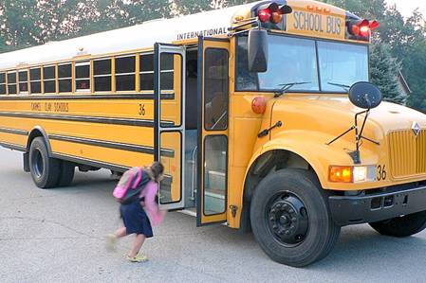Figure 1 Elana rushing to board the offending bus (#36) in 2006..

Question 1.

At the time, I was quite angry that Elana (age 7) needed to board (see Fig 1) at 7:25 to get to school (2 miles from our house) by 8:10. To convince the school system that this was unreasonable, I requested a comparison between the length (in time) of Elana’s bus ride and the average for all the kids in her school.

What should the school system provide to me besides THIS memo?

How should they calculate the average time on the bus for ALL children in the school system?

Step-by-step analysis.

- Plot the “Residue Function”(R(t)) for the children’s bus ride to school.
  - Label the axes of the plot.
  - Indicate for a given time, t, the number of children and the duration of their ride.
  - Using what we learned, write an expression for the mean transit time (MTT of children) on Elana’s bus.
  - Now lets figure out the MTT (Elana’s bus). Draw a DISCRETIZED version of R(t).
Trick Question Alert!
  - Label the plot carefully to indicate the number of children that get on the bus at any stop.
  - What is the impulse response function for this problem? Be very careful with this one.
  - Can you think of a biological problem that has this setup and this R(t)? (I cannot).

- What problem that is INTIMATELY related to the one above can be described with an ideal bolus injection?

- For both problems (1 and 2) plot the distribution of transit times, h(t).
  - indicate the location of the MTT. Is it the center of mass of the area under the curve?

- If (a) we KNOW the average speed of the bus and (b) we analogize LENGTH of bus route to VOLUME of tissue (Make sure to change your units), we can calculate the average length of a bus-ride. What is the relationship between MTT and bus-ride length and average speed? Do the units make sense?

