
NY Times

December 3, 2008

Cleveland Clinic Discloses Doctors’ Industry Ties
By REED ABELSON
The Cleveland Clinic plans to announce this week it has begun publicly reporting the business relationships that any of its 1,800 staff doctors and scientists have with drug and device makers.
The clinic, one of the nation’s most prominent medical research centers, is making a complete disclosure of doctors’ and researchers’ financial ties available on its Web site, www.clevelandclinic.org.
It appears to be the first such step by a major medical center to disclose the industry relationships of individual doctors. And it comes as the nation’s doctors and hospitals are under mounting pressure to address potential financial conflicts of interest that can occur when they work closely with companies to develop and research new drugs and devices.
The Cleveland Clinic’s Web postings are the most recent part of a conflict-of-interest effort at the clinic after some of its leading doctors came under fire several years ago when the news media disclosed some of their financial links.
“They are breaking a new path here,” said Dr. David J. Rothman, the president of the Institute on Medicine as a Profession, a nonprofit group based at Columbia University that studies potential conflicts of interest.
In American medicine, doctors’ links to industry are often hidden from public view. And critics argue that such relationships can taint the integrity of medical research and patient care. In one of the most recent controversies, a highly regarded and influential psychiatrist at Emory University, Dr. Charles B. Nemeroff, drew criticism in October for failing to disclose at least $1 million in consulting fees from drug makers.
Senator Charles E. Grassley, Republican of Iowa, has brought Congressional scrutiny to the issue and introduced legislation that would require drug and device makers to divulge the payments they make to doctors. In a statement, Senator Grassley praised the clinic’s move, citing it as evidence of change. “Patients deserve easy access to information about their doctors’ relationships with drug companies,” he said, “and the Cleveland Clinic is making that possible.”
Some drug companies, including Merck and Eli Lilly, say they plan to starting publicly disclosing their payments to doctors next year. Regulators have also forced some of the major makers of orthopedic devices to publish similar information on their Web sites as part of a government settlement. And a few states are following the example Minnesota set in 1993, requiring companies to disclose gifts to doctors valued at more than $100 in any given year.
“There is something of a movement,” said Dr. Rothman, although he added it was still “nascent.”
After the controversy a few years ago, the Cleveland Clinic undertook a significant review of its conflict-of-interest policies and developed a formal system of tracking the business dealings of its doctors and researchers. Those dealings, if they are deemed significant, undergo review by a conflict-of-interest committee.
The Cleveland Clinic says that fewer than a quarter of its doctors have anything to disclose. But Guy M. Chisolm III, the cell biologist who is chairman of the conflict-of-interest committee, says patients should know about such links so they can talk to their doctors or others at the clinic about any financial tie that raises questions.
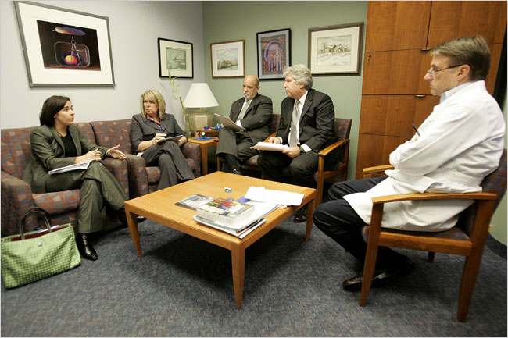
“Patients are vulnerable,” Dr. Chisolm said. Dr. Delos M. Cosgrove, a cardiothoracic surgeon who is the Cleveland Clinic’s chief executive, takes pride in the institution’s entrepreneurial zeal and active involvement in the research and development of drugs and medical devices. But he acknowledges that the environment has changed significantly in recent years as doctors’ industry relationships have come under scrutiny.
In fact, he considers some of that scrutiny to be excessive. “You can’t get a coffee mug from a drug company,” Dr. Cosgrove said.
His own business dealings, which were extensive when he became chief executive in 2004, have also been the subject of unflattering publicity. He has since severed his industry ties, including his previous oversight of the clinic’s own venture capital efforts, although he still receives royalties from five companies for his development of various heart devices.

y
 |  |  | TimesPeople Lets You Share and Discover the Best of NYTimes.com | 11:19 am
   | December 3, 2008
 |  | 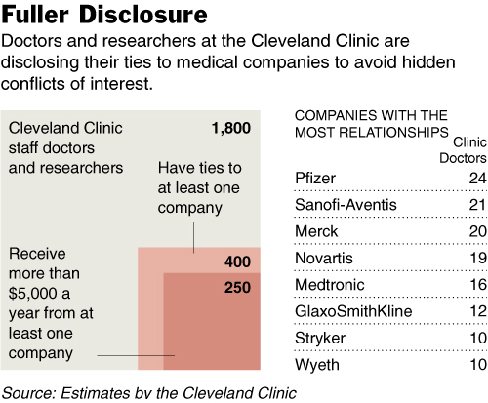
As Dr. Cosgrove sees it, potential conflicts of interest need to be managed, not automatically eliminated, because working with industry encourages innovation by the clinic and its doctors. He has even made “innovation management” part of the committee’s official title: the Cleveland Clinic Innovation Management and Conflict of Interest Committee.
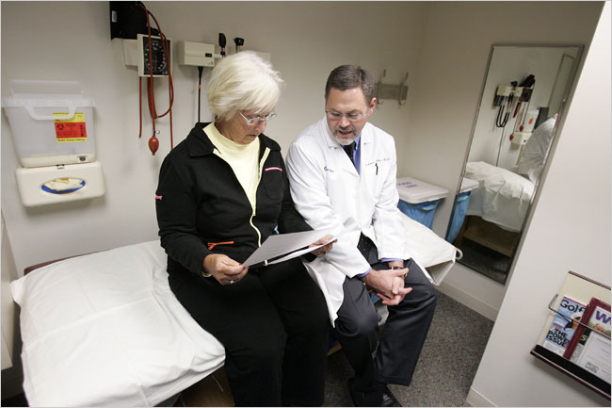

Mainly, he says, the Cleveland Clinic is committed to openness in all of its dealings. “We’re trying to be about transparency in everything we do,” he said, pointing to some of the clinic’s other efforts in publishing data on the outcomes of its care or giving patients easier access to their medical records.
Under the effort led by Dr. Chisolm, every scientist and doctor employed by the clinic must report any industry relationship to the clinic at least once a year. Members of the committee, which meets monthly, typically interview the doctors involved, often requiring documentation like letters to academic journals alerting editors to the industry relationships.
The clinic has been working for more than a year to set up the public listing on its Web site, where consulting payments of more than $5,000 a year, and all royalty and equity interests, will be disclosed.
“Disclosure is a minimum,” said Dr. Chisolm, who hopes to begin listing the actual dollar amounts involved in a doctor’s consulting arrangements next year. The current disclosure simply lists the companies for whom the consulting takes place. He said the group was planning to improve the clinic’s ability to audit the information it received from doctors, because the clinic must now rely on doctors’ self-reporting to find potential conflicts.
At a recent committee meeting, 16 people — clinic board members, lawyers, doctors and scientists — discussed the handful of cases before them. Although the proceedings of the committee are confidential, a reporter was allowed to attend on the condition that the companies and doctors involved would not be identified without their permission.
One case involved a retired doctor now working full time for a drug company. The doctor wanted to work with his former colleagues on some research projects at the clinic and to continue serving as a mentor there. During the discussion, one board member emphasized the importance of industry collaborations, but another argued that allowing such a relationship might suggest favoritism.
“There has to be equal footing with other competitors,” said Joseph M. Scaminace, a Cleveland business executive who is on the clinic’s board.
The committee decided to grant the doctor no special privileges.
In another case, a doctor developing educational materials with a company was required to submit for review any materials using the clinic’s name. In yet another matter before it, the committee gave approval to a doctor who wanted to collaborate with an investment firm, on the condition that the clinic’s lawyers review the contract.
The committee does sometimes ask doctors to choose between their consulting and research roles. Dr. Richard Grimm, a cardiologist, was a consultant for the device maker Medtronic, receiving more than $10,000 a year, the limit above which a doctor or researcher must get special approval to continue related research. Last year, he was asked either to stop overseeing clinic research involving a Medtronic device or to do less consulting.
“I sincerely never felt that one was having any effect on the other,” recalled Dr. Grimm, but he chose to scale back his consulting. “One of the main reasons I’m at the clinic is to have involvement in teaching and research,” he said.
Among the most difficult potential conflicts to manage are those that involve the clinic’s own entrepreneurial activities. In one case, the clinic is undertaking research about a medical treatment after surgery developed by one of its own start-up companies. The committee, working with the clinic’s board, developed a management plan that barred any of the research being conducted by someone directly involved in the company. And it called for the possible review of the research findings by an independent party.
Some critics argue that the clinic applies its rules only when convenient.
Last December, the clinic was sued over charges of defamation and related claims by a doctor whose contract had not been renewed because the clinic said he had not disclosed all of his industry ties. In the lawsuit, which is still pending, Dr. Sanjay Yadav, a cardiologist, cites what he describes as “widespread and pervasive conflicts of interest” at the Cleveland Clinic. The clinic declined to comment on the suit.
Some experts wonder how useful the industry disclosures actually are to patients when they are told of a doctor’s industry ties before agreeing to take part in a research trial. A patient, they argue, may not know what to make of such information.
“It’s not like telling patients there’s a chance they are going to have a headache,” said Dr. Kevin P. Weinfurt, an associate professor at the Duke Clinical Research Institute, who has studied patients’ opinions about potential conflicts.
Dr. Cosgrove says the clinic’s efforts, like those of the country’s other medical centers, are still a work in progress.
“This is a moving target,” he said, “and it’s obviously moved a long ways in the last 20 years.”

